Collector User Guide

**Creating your working map on iPad:**

1. Connected to WIFI, login to Collector of the iPad.
2. Select ‘All’ at the top to see all layers on ArcGIS.com.
3. Download the layer you want to use by selecting the cloud with arrow icon in lower right of the layer (if the layer has a cloud with 2 arrows, it’s already downloaded onto the iPad).

1. Next, choose a new basemap.

1. Choose your work area. Make sure it encompasses the entire area of your survey. Points that fall out of the work area will not be recorded.

1. Once your work area is set, select ‘Map Detail’ and zoom in to the desired detail for using the map. Select ‘Download’ in upper right.

1. After the layer has downloaded, select ‘On Device’ at the top of screen. The layer and basemap should now be on the iPad.

**Changing locations of your working map on iPad:**

Say you want to change your map to one specific tributary or you go to a different watershed like the Secesh or North Fork but you want to use the same layer.

1. Go to your maps ‘On Device’ on Collector.
2. Select ‘Manage’ under the drop-down list under the page with arrow icon.

1. Select ‘Remove’ on the desired layer then select ‘Done’ in the upper right of the screen.

1. Once your desired layer and map are removed, use steps from “Creating your working map on Ipad” above.

**Getting points collected to .csv:**

1. Once you’re back at the office and connected to WIFI go to your ‘Maps’ on Collector on the iPad and upload your points on Lemhi_CU_2020. This will be a red button at the bottom with the number of points you’ve collected so far. Pushing the button, Collector will sync with the cloud.

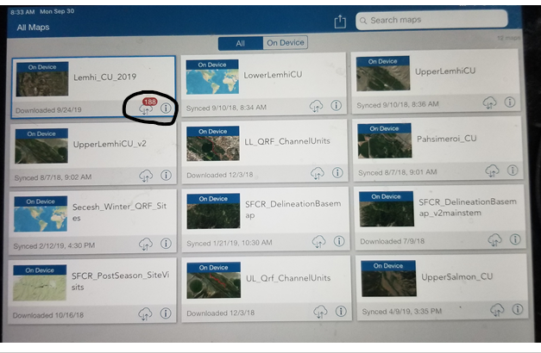

2. Log onto ArcGIS online (arcgis.com) using Richie’s account: [richie@qcinc.org](mailto:richie@qcinc.org). If you don’t know his password, call me.

3. Select ‘Content’ at the top of the page.

4. Next, click on the Web Map ‘Lemhi_CU_2019’ from the content list.

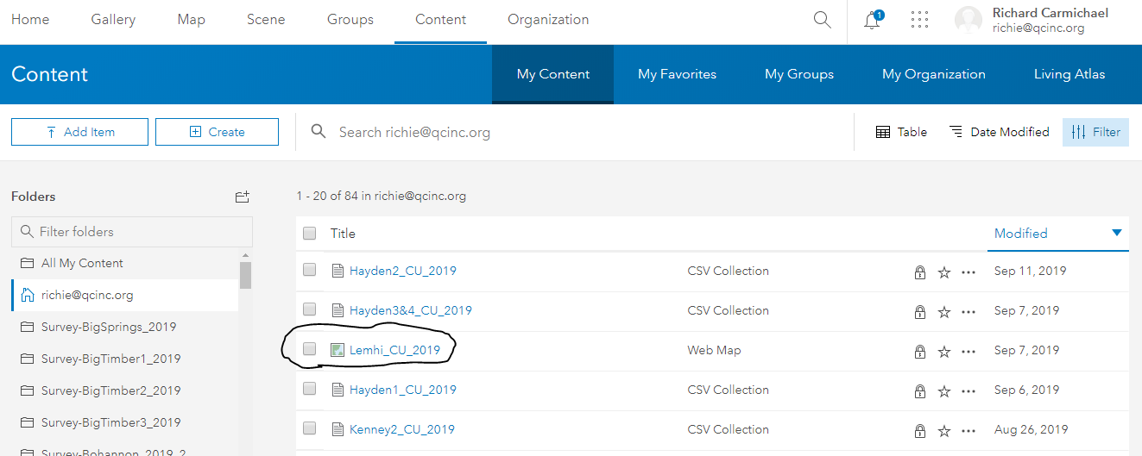

5. Click on ‘Map Viewer’ in the right-hand corner.

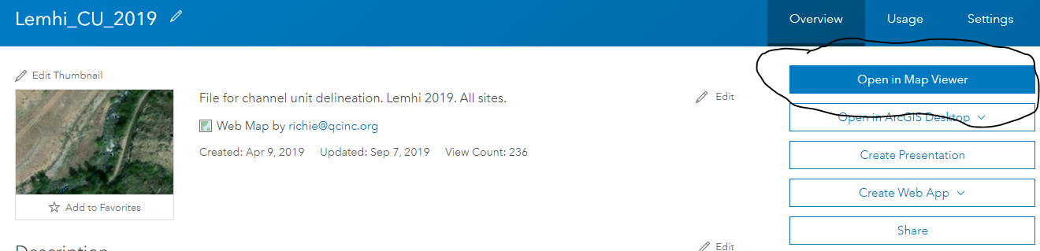

This will allow you to view your points and see if any fall out of the channel and you can make edits. You will likely need to navigate to the points you collected by scrolling out and moving the map around to the appropriate drainage.

6. Click ‘Content’ again at the top of the page.

7. Scroll through the content list until you find the Feature Layer (hosted) ‘Lemhi_CU_2019’ (may be on page 2 or 3) and click on it.

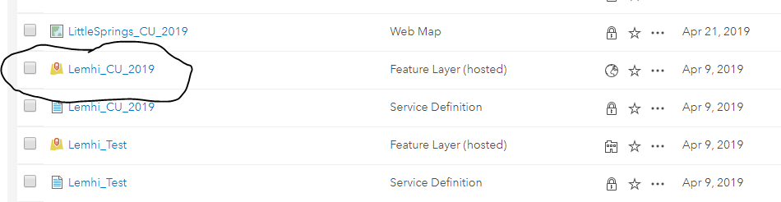

8. Click on ‘Export to CSV file’ in the drop-down menu under ‘Export Data’.

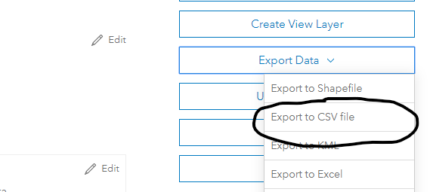

9. Next, you need to fill in a couple of rows. Change the ‘Title’ from Lemhi_CU_2019 to the appropriate transect name (see below). For ‘Tags’ fill in the name of the creek and for ‘Summary’ fill in ‘channel units’ then click ‘Export’.

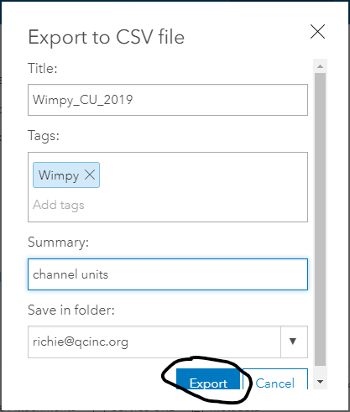

10. Next, select ‘Download’

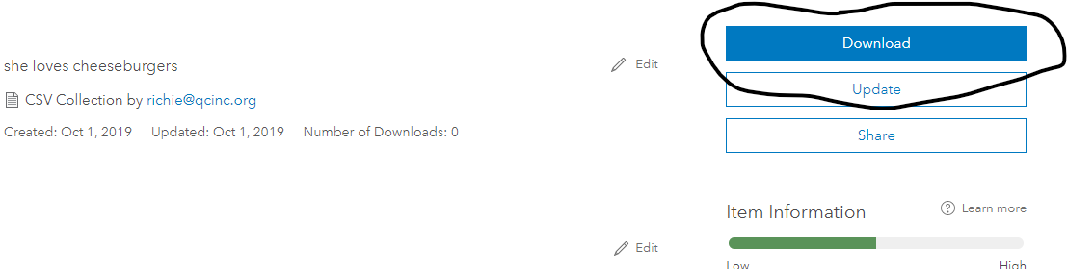

11. This will create a folder with the CSV ‘Lemhi_CU_2019’ in it (appears at the bottom of the screen). This CSV will have all the points taken for the year in the Featured Layer Lemhi_CU_2019. That’s why it’s important to label the first 3 and last 3 points taken on a transect with the site name (Hayden2_2019) and creek name. Navigate to the list of points you’re looking for (the last points taken will be at the bottom of the CSV because they’re listed chronologically). Cut or copy the points you want into a new CSV with the appropriate naming convention (Hayden2_CU_2019). Make any necessary edits (duplicate or missing CU, segments, etc.).